# TCES 455, Autumn 2016

# Laboratory 5: DC Water Tank Level Control - Again

### Objective

The objective of this laboratory exercise is to develop a feedback control system that regulates the water level in a tank. Refer to Figure 1, below.

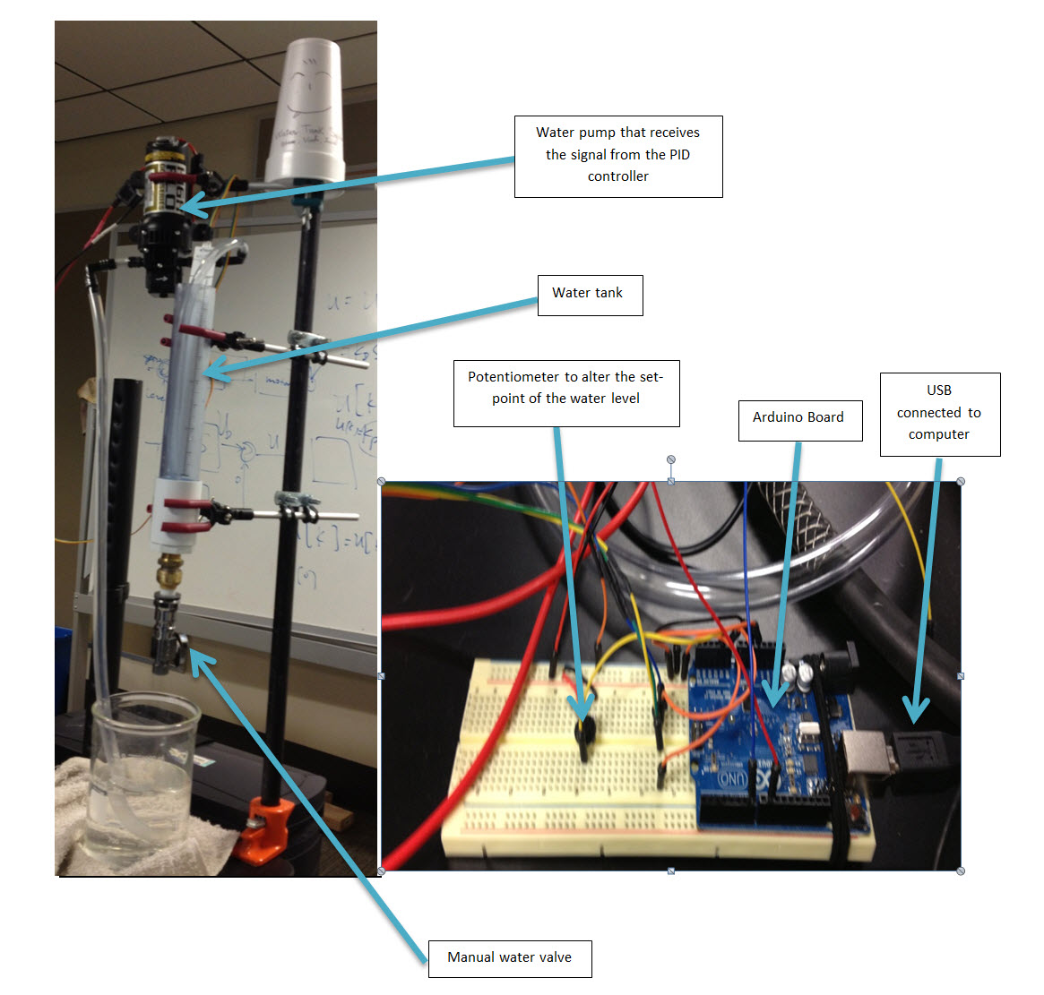

Figure 1. The Setup (Photos by Phan, Mertens, and Mackey)

During normal operation, the valve at the bottom of the tank is open and the control system controls the speed of the pump, which, in turn, controls the rate of flow into the tank. The tank level is measured by a pressure sensitive tape which changes resistance as the water level changes. A potentiometer allows the user to change the water level set point.

Design your control system to use at least two elements of a PID controller (PD, PI, or PID).

Also for this lab, you may use any Library and Matlab/Simulink to help accomplish this. You will NOT have to turn in this code.

Also, each person needs to complete the group evaluation form. If you decide to just give everyone full credit even if they do not deserve it, I will know and both of you will receive a zero. It’s ok to give full credit when it’s due, the results of the group grades will be made public after the final project is complete. I will speak to anyone receiving poor grade from the groups in such a manner that will preserve the anonymity of the graders.

### Theory of Operation

Figure 2 depicts an ideal water tank.

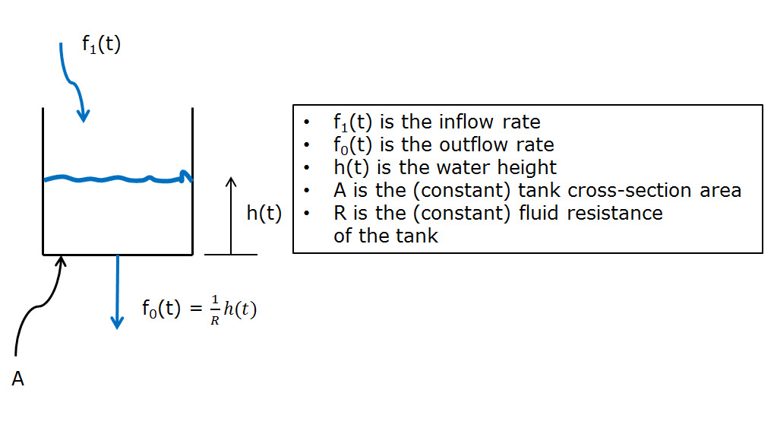

Figure 2. Ideal Tank

We found the governing differential equation to be

$$A\frac{dh(t)}{dt}+\frac{1}{R}h\left(t\right)=f_{1}(t)$$

which is equivalent to the transfer function

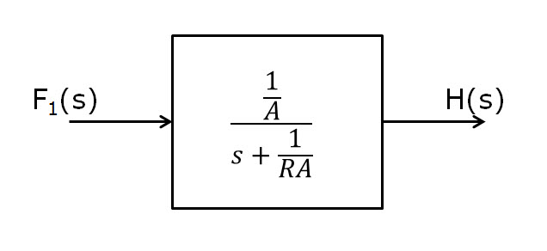

Figure 3. Ideal Tank Transfer Function

Call this transfer function T(s).

Our control system block diagram will look like Figure 3.

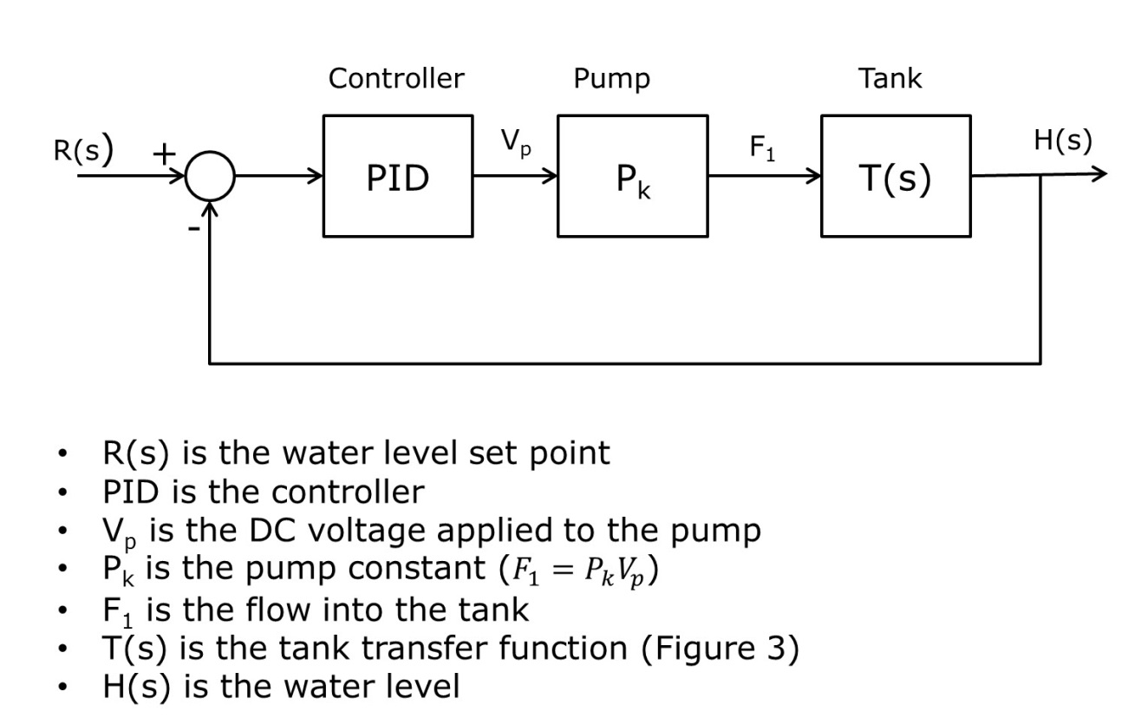

Figure 4. Closed Loop System

### Simulation

You will have to measure or set up tests to measure, if you were smart and listened you should have made sketches to help with this.

* The tank cross sectional area, A
* The fluid resistance, R
* The pump constant Pk

Once you have these constants, use Matlab/simulink to see if you can find a suitable PID controller. Test your controller in Matlab with a step input and see if you can get a response of

* Rapid rise time
* No overshoot
* Water height tracks set point one for one.

### Implementation

Use your Arduino to implement this control system. Use timer/counter 3 to cause your controller to run at exact times (say, 10 times per second). This will give you a precise ∆t to use in your PID calculations. Use the PID coefficients you found by simulation as starting points and adjust as necessary to achieve a good level controller.

Use a potentiometer as shown in Figure 1 to adjust the set point.

### The Notebook:

Individually, annotate in your lab notebook what you have done here. It should contain

* The names of the people in your group
* The objective
* The measurements and tests you did to find any necessary constants for the transfer functions (you can include your tape measurements in this part).
* The theory of operation (in your words)
* The simulation (graphs, figures, all of your results, and a discussion covering why you chose the particular controller you came up with)
* The implementation
  + A detailed list of all the hardware you used
  + A detailed block diagram showing units conversions, etc.
  + A discussion of the results of all your testing (how did the system behave with the constants you found by simulation, what did you change to get better results)
  + The final PID controller you settled on
* Compare lab 3 and 5
  + Describe how you approached them, if different.
  + How long did they take and why you think it was this way.
  + Any other things you found interesting between them
* Conclusions should concentrate on differences in behavior between simulation and implementation. Include anything else you found interesting.